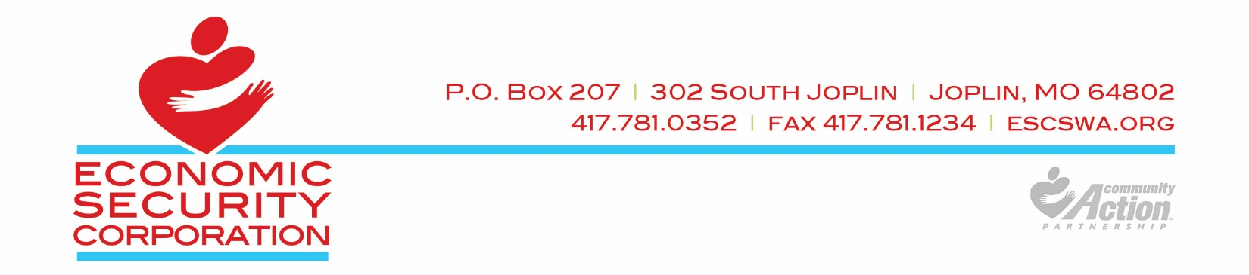June 20, 2022
Dear Policy Council Member:
We will meet via Google Meeting. I hope you will be able to call in or join.

Meeting Date:
- June 28, 2022 Time: 6:30 P.M.

To participate in this meeting you have several options.

First, you can come to one of the following Head Start centers:

Noel Head Start – 628 Johnson Drive , Noel MO | Carthage Planning Center – 739 E 7th St , Carthage MO
Sarcoxie Head Start – 101 North 17th Street , Sarcoxie | Neosho Head Start – 750 National Guard Rd, Neosho
Webb City Head Start – 300 North College ,Webb City | North Joplin – 1200 North Main Street , Joplin MO
South Joplin Head Start – 4302 Richard Joseph Blvd West , Joplin | Longview Head Start – 16381 E. State Hwy 76, Rocky Comfort MO
Each of these sites will be logged on to the meeting and you can participate from there. There will be no childcare available. However, a $20 childcare stipend is available if you qualify.

Secondly, you can join the meeting from your home by following one of the options below:
Joining from home:
Please mute your phone or computer microphone after announcing your name.

Meeting ID
meet.google.com/koi-dgdc-fhe
Phone Numbers
(US‬)+1 617-675-4444‬
PIN: 483 598 254 7271#‬

Sincerely,

ECONOMIC SECURITY CORPORATION

Leisa Harnar and Kathy Miller
Head Start/Early Head Start
HEAD START/EARLY HEAD START - POLICY COUNCIL MEETING
June 28, 2022 Time: 6:30 pm
“We will make a difference in the lives of children and families”
AGENDA
Three ways to join: Go to one of the centers identified in the letter, or join from home using one of the options below:

Join with Google Meet:  Meeting ID  meet.google.com/koi-dgdc-fhe | Or, call in with this Phone Number:  (US‬)+1 617-675-4444‬  PIN: 483 598 254 7271#‬

MEETING CALLED TO ORDER …………..…………………………………………………………….. Policy Council Co-Chair – Walter Taylor
Roll Call …………………………………………………………………………………….…………………….. Ashley Dickenson
ITEMS FOR APPROVAL:
- Approval of April’s Meeting Minutes ……………………………………………………. Walter Taylor
- Approval of Consent Agenda Items (April & May)…………………………………... Walter Taylor
ITEMS FOR REVIEW:
- Review of Parent Survey …………………..…………………………………………………………. Kelly Creech
- School Readiness Reports ……………………………………………………………………………. Cindy Ladbasri

ITEMS FOR APPROVAL:
5. Self-Assessment Results ……………………………………………………………………………… Kathy Miller
6. Agency Grievance Policy …………………………………………………………………………….. Leisa Harnar
7. Head Start/Governing Board Impasse Policy ……………………………………………… Leisa Harnar

BOARD LIAISON REPORT
8. Update from Board Liaison ……………………………………………………………………………. Rito Sosa

DIRECTOR’S REPORT
- Update from Head Start/Early Head Start Director …………………………………….….. Leisa Harnar

Closing Announcements – PC Co-President – Walter Taylor
Next meeting: July 26, 2022
Adjourn – PC Co-President – Walter Taylor

Important – To obtain copies of this agenda or to place discussion items on the agenda for future Policy Council Meetings, contact Leisa Harnar, ESCSWA, 302 Joplin Ave, PO Box 207, Joplin MO 64802-0207. Agenda items must be received at least 2 week prior to the regularly scheduled meeting.

