Jasper County Public Housing Agency (JCPHA)
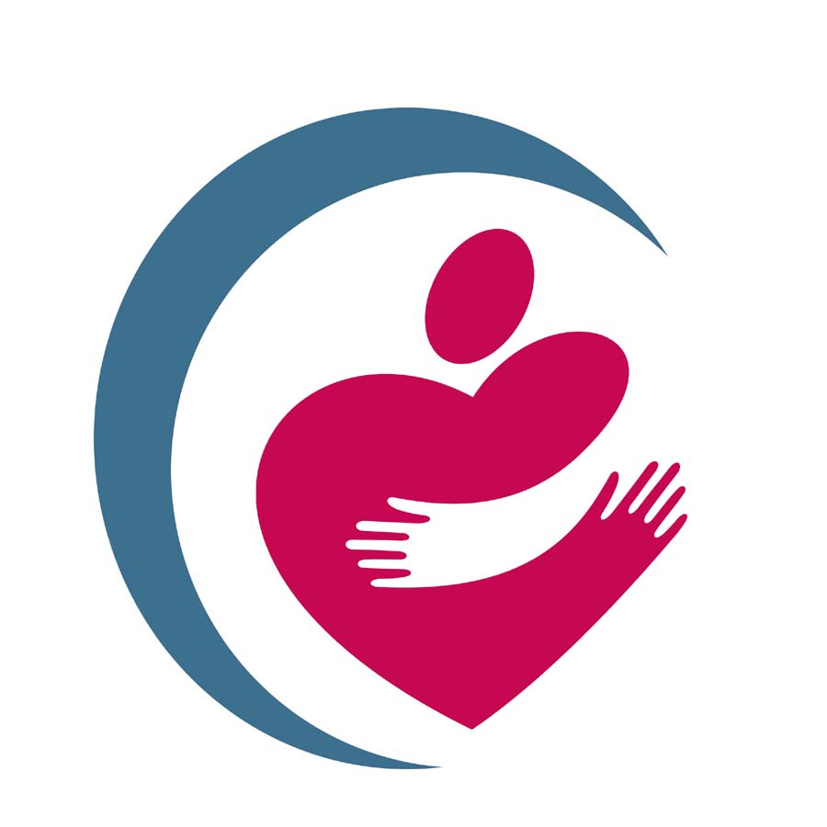
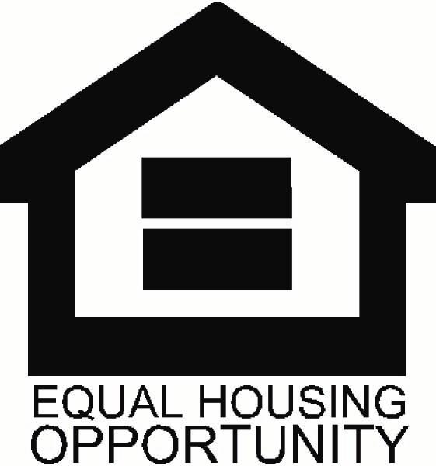
302 Joplin Street
Joplin, MO 64802

Program Eligibility
2022
Effective 04/18/2022

Jasper and Newton County

Family Size 50 % (Very Low)
1 person $21,100
2 persons $24,100
3 persons $27,100
4 persons $30,100
5 persons $32,550
6 persons $34,950
7 persons $37,350
8 persons $39,750

Barton County

Family Size 50 % (Very Low)

1 person $19,750
2 persons $22,550
3 persons $25,350
4 persons $28,150
5 persons $30,450
6 persons $32,700
7 persons $34,950
8 persons $37,200

McDonald County

Family Size 50 % (Very Low)

1 person $19,750
2 persons $22,550
3 persons $25,350
4 persons $28,150
5 persons $30,450
6 persons $32,700
7 persons $34,950
8 persons $37,200

